
Submitted by:
Name: Istiak Alam
ID: 05
Batch: 20
Lab report: 04
Date: 6.11.22
Course: CSE LAB
Course Code: 1202
Assignment Topic: Structured Programming Problems Solve & description

Submitted to:
Nafisa Tabassum
LECTURER, NDUB

Problem No. 01
Name of the problem:
Take values of length and breadth of a rectangle from user and check if it is square or not.

Introduction
Implementing program in C is very interesting. To implement the problem given above we should remember the procedure to display outcome. That is, we should consider about the required inputs, the particular process that will be applied upon the input data and the output whether it is desired or not. The given problem gives me an opportunity to have an exercise on the procedure.

Program:
#include<stdio.h> int main ()
{ int x,y;
printf("Enter your length of the rectangle:"); scanf("%d",&x);
printf("Enter your length of the rectangle:"); scanf("%d",&y);
if(x==y)
printf("This is a Square"); else if(x>y || y>x)
printf("This is a rectangle"); else
printf("your input is in valid"); return 0;
}

Output:
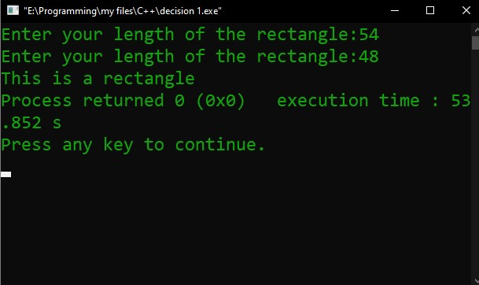
Figure 1 Output

Problem No. 02
Name of the problem:
Take two int values from user and print greatest among them.

Introduction
Implementing program in C is very interesting. To implement the problem given above we should remember the procedure to display outcome. That is, we should consider about the required inputs, the particular process that will be applied upon the input data and the output whether it is desired or not. The given problem gives me an opportunity to have an exercise on the procedure.

Program:
#include<stdio.h> int main ()
{ int x,y;
printf("Enter Any two numbers:\n"); scanf("%d %d",&x,&y);
if(x>y)
printf("The greatest number is %d",x); else if(y>x)
printf("The greatest number is %d",y); else
printf("Those number are equal"); return 0;
}

Output:
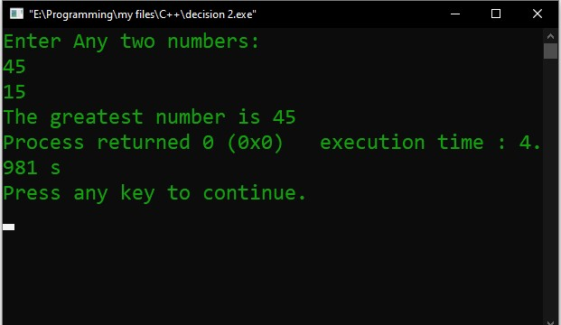
Figure 2 Output

Problem No. 03
Name of the problem:
Write a C program to input amount from user and print minimum number of notes (TK. 1000, 500, 100, 50, 20, 10, 5, 2, 1) required for the amount.

Introduction
Implementing program in C is very interesting. To implement the problem given above we should remember the procedure to display outcome. That is, we should consider about the required inputs, the particular process that will be applied upon the input data and the output whether it is desired or not. The given problem gives me an opportunity to have an exercise on the procedure.

Program:
#include<stdio.h> int main ()
{
int a,b=0,c=0,d=0,e=0,f=0,g=0,h=0,i=0,j=0,k=0;
printf("notes of taka: TK. 1000,500,100,50,20,10,5,2,1\n"); printf("Enter the amount:"); scanf("%d",&a);
printf("Total number of notes:"); if(a>=1000)
{
b=a/1000;
a=a%1000;
}
if(a>=500)
{
c=a/500;
a=a%500;
}
if(a>=200)
{
d=a/200;
a=a%200;
}
if(a>=100)
{
e=a/100; a=a%100;
}
if(a>=50)
{
f=a/50; a=a%50;
}
if(a>=20)
{
g=a/20; a=a%20;
}
if(a>=10)
{
h=a/10; a=a%10;
}
if(a>=5)
{ i=a/5;
a=a%5;
}
if(a>=2)
{ j=a/2;
a=a%2;
}
if(a>=1)
{
k=a/1;
a=a%1;
}
printf("\n 1000:%d \n 500:%d \n 200:%d \n 100:%d \n 50:%d \n 20:%d \n 10:%d \n 5:%d \n
2:%d \n 1:%d",b,c,d,e,f,g,h,i,j,k);
return 0; }
Output:
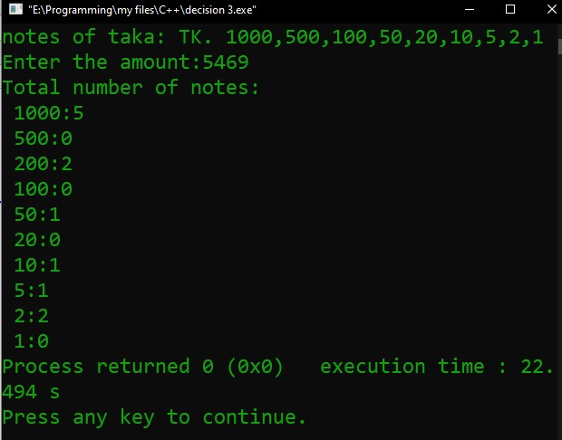

Figure 3 Output

Problem No. 04
Name of the problem:
A shop will give discount of 10% if the cost of purchased quantity is more than 1000. Ask user for quantity suppose, one unit will cost 100. Judge and print total cost for user.

Introduction
Implementing program in C is very interesting. To implement the problem given above we should remember the procedure to display outcome. That is, we should consider about the required inputs, the particular process that will be applied upon the input data and the output whether it is desired or not. The given problem gives me an opportunity to have an exercise on the procedure.
Program:
#include<stdio.h> int main ()
{ int x,y;
printf("Enter the amount of your quantity:"); scanf("%d",&y); x= y*100; if(x>1000)
{
y= (x*10)/100;
y= x-y;
printf("Discount cost is %d",y);
}
else
printf("You have no Discount..\n Total cost %d",x); return 0;
}

Output:

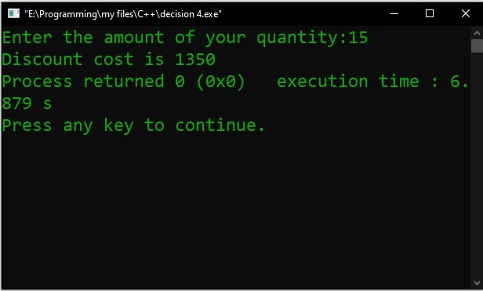
Figure 4 Output

Problem No. 05

Name of the problem
A company decided to give bonus of 5% to employee if his/her year of service is more than 5 years. Ask user for their salary and year of service and print the net bonus amount.

Introduction
Implementing program in C is very interesting. To implement the problem given above we should remember the procedure to display outcome. That is, we should consider about the required inputs, the particular process that will be applied upon the input data and the output whether it is desired or not. The given problem gives me an opportunity to have an exercise on the procedure.

Program:
#include<stdio.h> int main ()
{
int x,y,z;
printf("Enter your salary:"); scanf("%d",&x);
printf("Enter year of service:"); scanf("%d",&y); if(y>5)
{
z=(x*5)/100; z=x+z;
printf("The bonus amount of employee is: %d",z);
}
Else
printf("Sorry you have no bonus..."); return 0;}

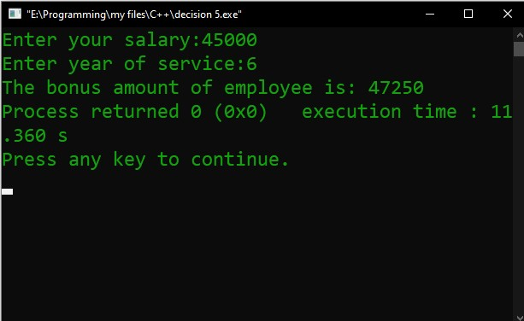
Figure 5 Output

Problem No. 06
Take input of age of 3 people by user and determine oldest and youngest among them.

Introduction
Implementing program in C is very interesting. To implement the problem given above we should remember the procedure to display outcome. That is, we should consider about the required inputs, the particular process that will be applied upon the input data and the output whether it is desired or not. The given problem gives me an opportunity to have an exercise on the procedure.
Program;
#include<stdio.h> int main ()
{
int x,y,z;
printf("Enter the 1st age:\n"); scanf("%d",&x);
printf("Enter the 2nd age:\n"); scanf("%d",&y);
printf("Enter the 3rd age:\n"); scanf("%d",&z); if(x>y && x>z)
{printf("1st person is Oldest person\n");
(y<z)? printf("2nd person is youngest\n"):printf("3rd person is youngest\n");} else if(y>x && y>z)
{printf("2nd person is Oldest person\n");
(x<z)? printf("1st person is youngest\n"):printf("3rd person is youngest\n");} else if(z>x && z>y)
{printf("3rd person is Oldest person\n");
(x<y)? printf("1st person is youngest\n"):printf("2nd person is youngest\n");} else
printf("Those number are equal"); return 0;
}

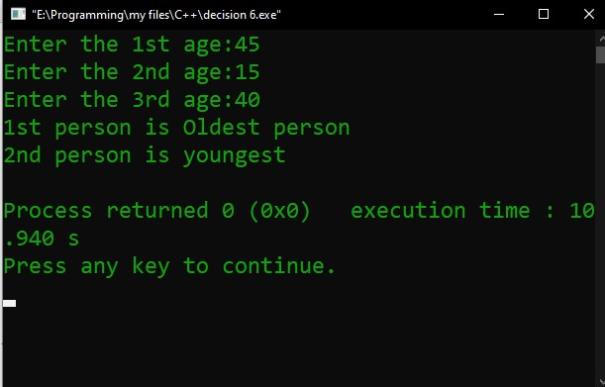
Output 6

Problem no. 07
Write a C program to print absolute value of a number entered by user.

Introduction
Implementing program in C is very interesting. To implement the problem given above we should remember the procedure to display outcome. That is, we should consider about the required inputs, the particular process that will be applied upon the input data and the output whether it is desired or not. The given problem gives me an opportunity to have an exercise on the procedure.
Program:
#include<stdio.h> int main ()
{ int x,y; printf("INPUT:"); scanf("%d",&x); if(x<0) printf("OUTPUT:%d",x*-1); else
printf("OUTPUT:%d",x); return 0;
}

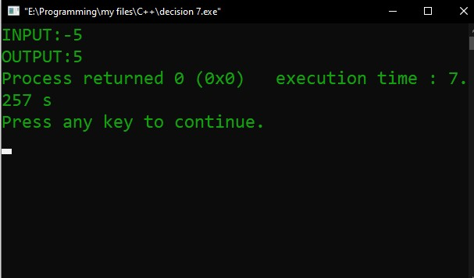
Figure 6

Problem No. 08
A student will not be allowed to sit in exam if his/her attendance is less than 75%.

Introduction
Implementing program in C is very interesting. To implement the problem given above we should remember the procedure to display outcome. That is, we should consider about the required inputs, the particular process that will be applied upon the input data and the output whether it is desired or not. The given problem gives me an opportunity to have an exercise on the procedure.
Program:
#include<stdio.h>
int main ()
{
int x,y,z;
printf("Number of classes held:"); scanf("%d",&x);
printf("Number of classes attented:"); scanf("%d",&y); z=((y*100)/x);
printf("Your attendance is %d%c\n",z,37); if(z>=75)
printf("You will be allowed to sit in exam\n\n"); else
printf("You will not be allowed to sit in exam.\nBecause, your attendance is less then
75%c\n\n",37);
return 0;
}

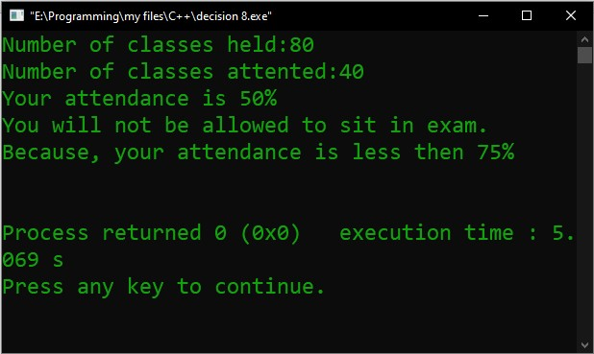

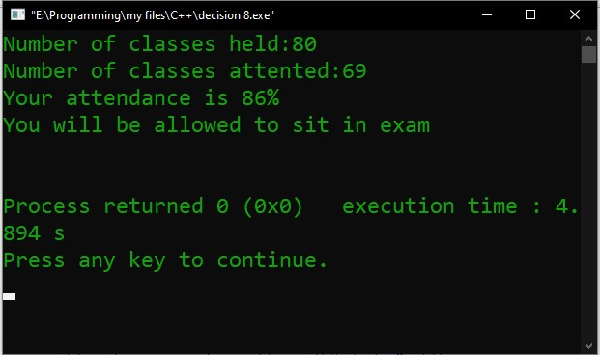

Problem No. 09
Write a C program to check if a year is leap year or not.

Introduction
Implementing program in C is very interesting. To implement the problem given above we should remember the procedure to display outcome. That is, we should consider about the required inputs, the particular process that will be applied upon the input data and the output whether it is desired or not. The given problem gives me an opportunity to have an exercise on the procedure.
Program:
#include<stdio.h>

int main ()
{ int y;
printf("Enter year:");
scanf("%d",&y);

if(y%4==0)
printf("This year %d is Leap year",y); else if(y==2000 || y==1900 || y==2100)
(y%400==0)? printf("This year %d is Leap year",y) : printf("This year %d is not Leap year",y); else
printf("This year %d is not a Leap year",y);

return 0;

}

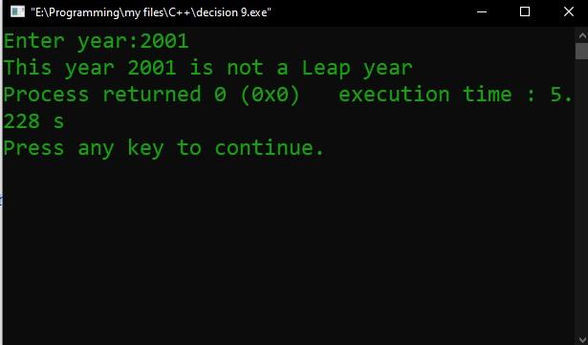 output

Problem No. 10
Admission to a professional course in subject to the following conditions: a) Marks in mathematics >=60
- Marks in Physics >=50
- Marks in Chemistry >=40
- Total in all three subjects >=200 or
Total in mathematics and physics>=150.
Given the marks in the three subjects, write a program to process the applications to the eligible candidates.

Introduction
Implementing program in C is very interesting. To implement the problem given above we should remember the procedure to display outcome. That is, we should consider about the required inputs, the particular process that will be applied upon the input data and the output whether it is desired or not. The given problem gives me an opportunity to have an exercise on the procedure.
Program:
#include<stdio.h> int main ()
{
int m,p,c,total; printf("Mark in math:"); scanf("%d",&m); printf("Mark in physics:"); scanf("%d",&p);
printf("Mark in chemistry:"); scanf("%d",&c); total= m+p+c;
printf("Your total marks is:%d\n",total); if(m>=60 && p>=50 && c>=40 && total>=200) printf("You are eligible candidates"); else
printf("You are not eligible") return 0;
}

Output:

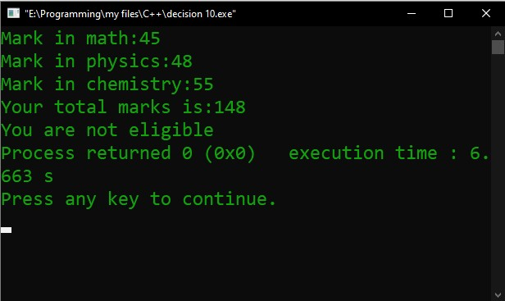

THE END

